1. Command: whoami
Description: Displays current user account
Example: whoami

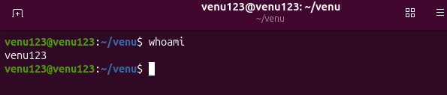

2 Command: ls

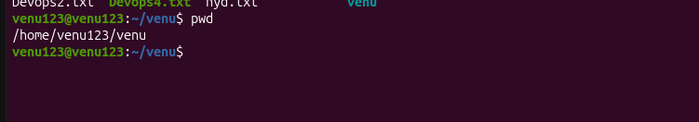
3.Command: pwd
Description: Shows current working directory path
Example: pwd

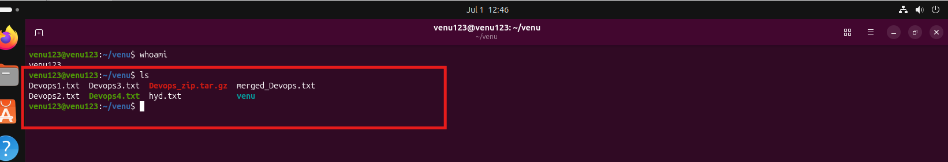

4. Command: ip a
Description: Lists IP addresses and network interfaces
Example: ip a

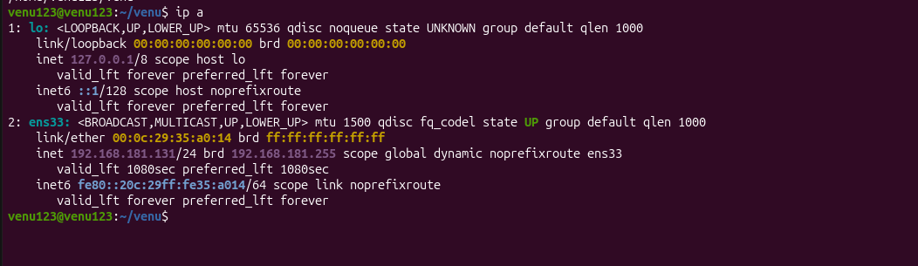

5. Command: passwd
Description: Changes current user account password
Example: passwd

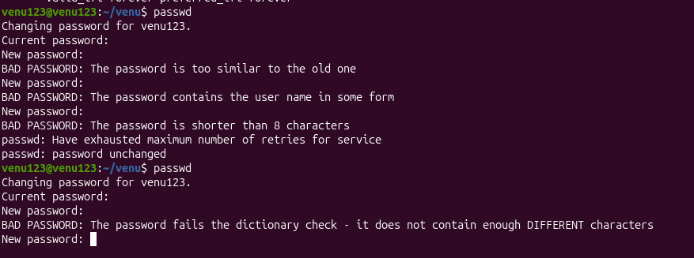

6. Command: touch
Description: Creates empty files to test write access
Example: touch newfile.txt
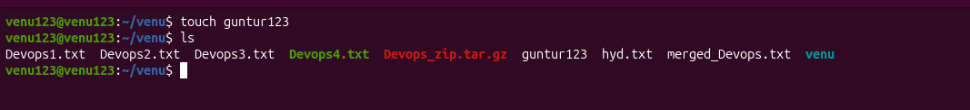

7. Command: man
Description: Accesses system manual for commands
Example: man ls
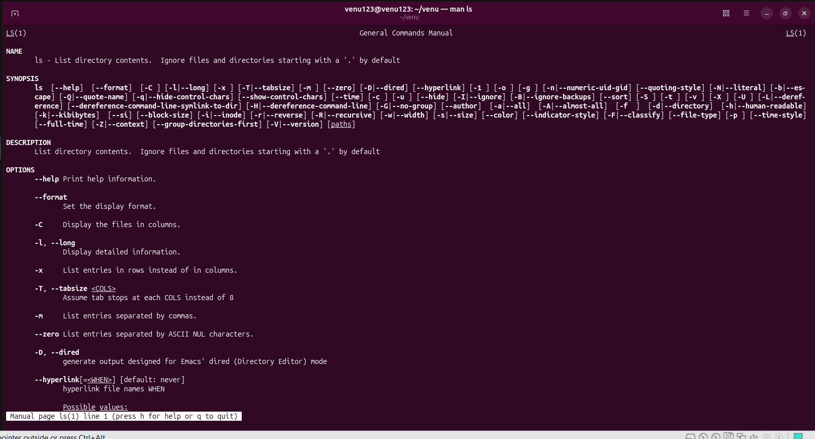

8. Command: apropos
Description: Searches command descriptions for keyword matches
Example: apropos "list files"

Command: pinfo
Description: Provides detailed system documentation pages
Example: pinfo ls
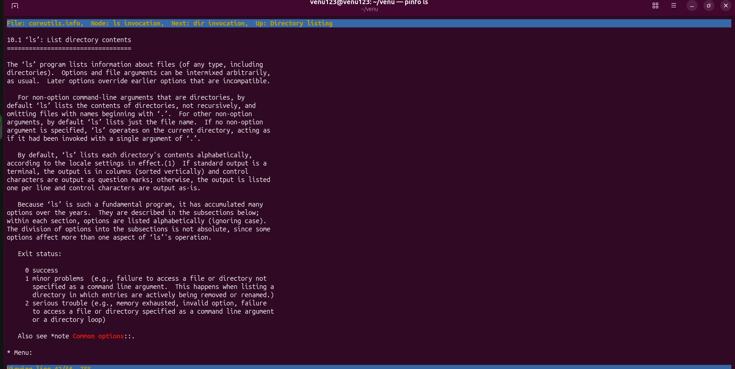

Command: tldr
Description: Shows simplified practical command examples
Example: tldr passwd

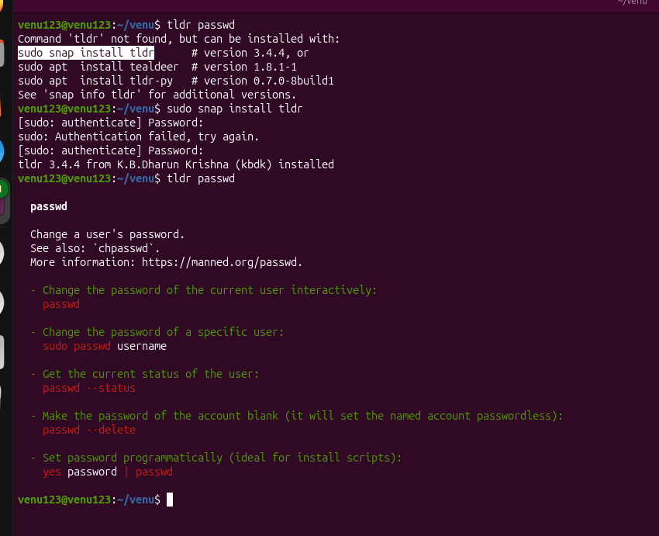

🛠️ Essential File Management
Command: ls
Description: Lists files within specified path
Example: ls /home/user/Documents
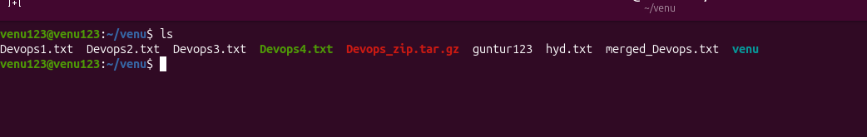

Command: cp
Description: Copies files or directories to new location
Example: cp source.txt destination.txt
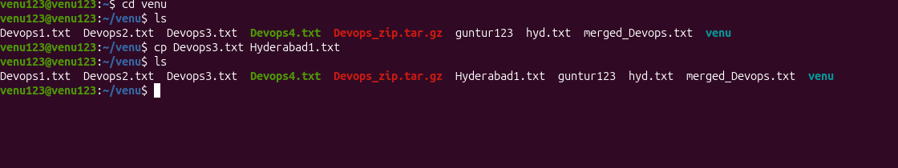

Command: mkdir
Description: Creates new empty directory folder
Example: mkdir new_directory
Command: rmdir
Description: Removes empty directory folders only
Example: rmdir empty_directory
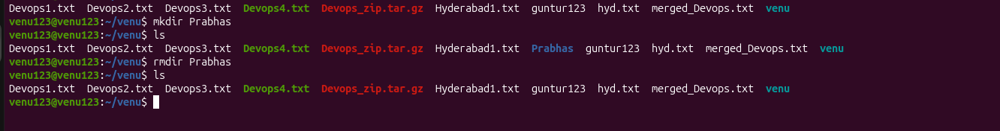
Command: mv
Description: Moves or renames files and directories
Example: mv oldname.txt newname.txt
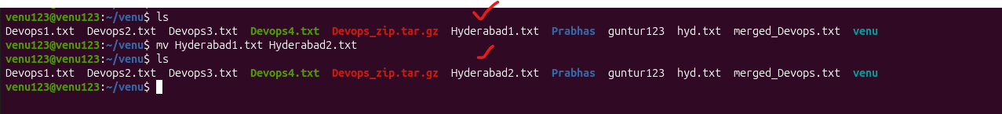
Command: rm
Description: Removes files or specified directories
Example: rm filename.txt
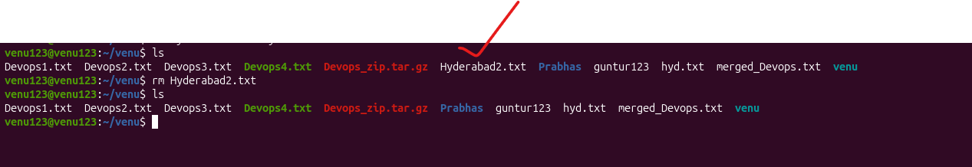
Command: rm -rf
Description: Forces recursive deletion without prompting
Example: rm -rf directory_name
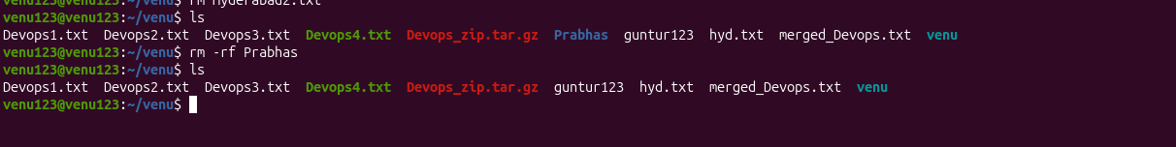

🚀 Advanced File & Disk Management
Command: ln -s
Description: Creates symbolic link to file or folder
Example: ln -s source_file symbolic_link
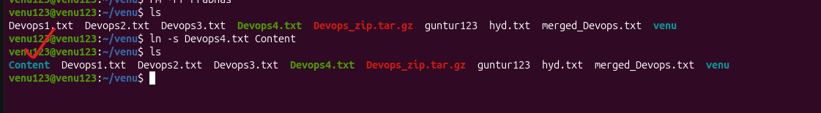

Command: find
Description: Searches files by attributes like name or size
Example: find /home -name "*.txt"
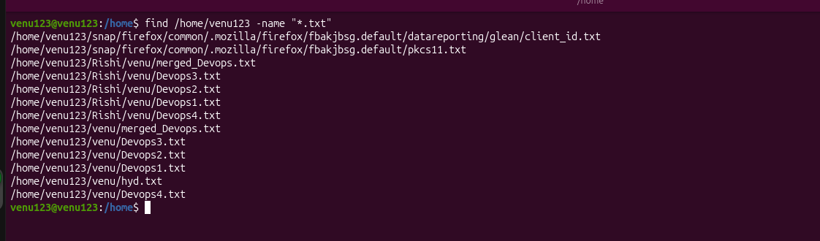

Command: locate
Description: Fast file searching using indexed system database
Example: locate filename
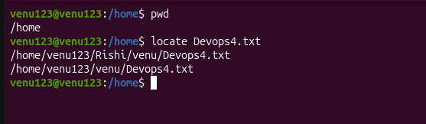
Command: which
Description: Finds executable path location within system PATH
Example: which python
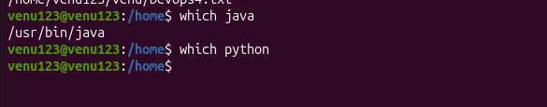
Note: if it is not installed in Linux will not show output

Command: tar
Description: Archives multiple files into single tarball bundle
Example: tar -cvf archive.tar /folder
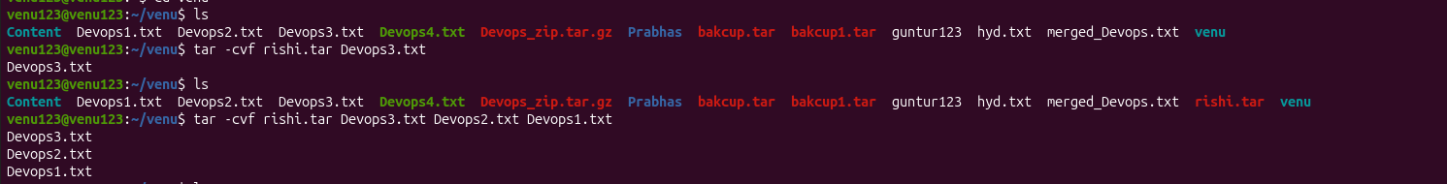

Command: gzip
Description: Compresses files to reduce disk size
Example: gzip file.txt
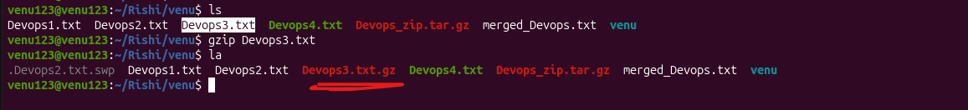

Command: bzip2
Description: Compresses files with high efficiency ratio
Example: bzip2 file.txt
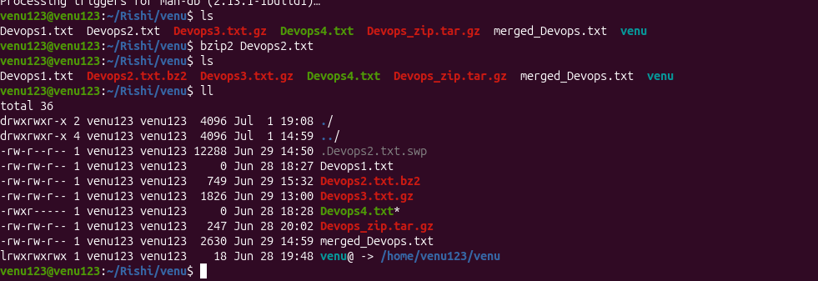

Command: xz
Description: Compresses files using highest ratio utility
Example: xz file.txt
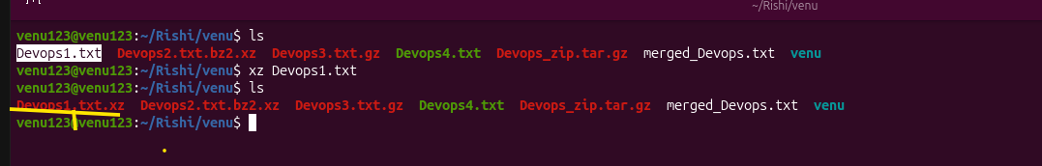
Command: zip
Description: Packages and compresses files into .zip format
Example: zip archive.zip file1 file2
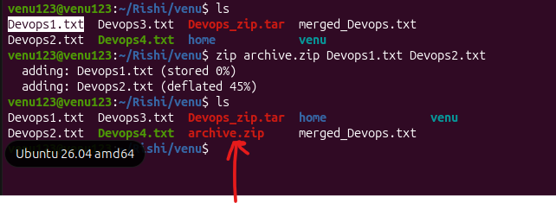
Command: file
Description: Determines specific file format type properties
Example: file image.jpg
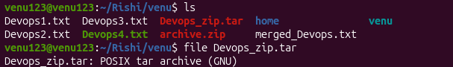

Command: mount
Description: Attaches storage device filesystems to directory
Example: mount /dev/sdb1 /mnt
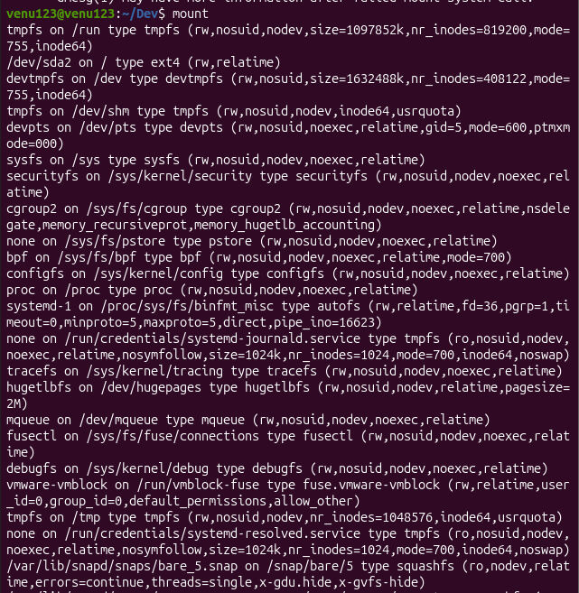
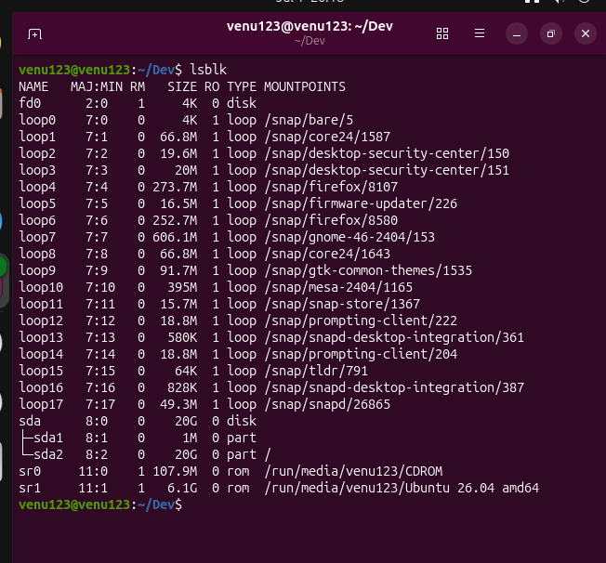
Command: df -h
Description: Displays free disk space in human format
Example: df -h

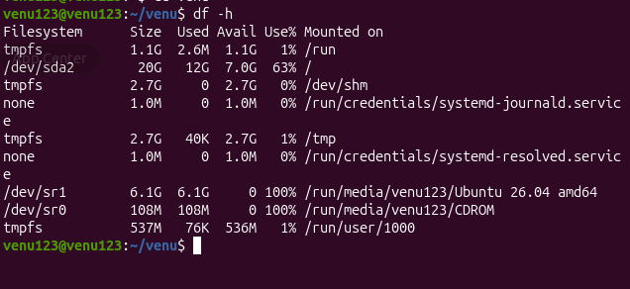

Command: findmnt
Description: Lists mounted filesystems in tree structure
Example: findmnt -t ext4

The findmnt command is a modern, powerful alternative to the older mount and df commands. Its main purpose is to search and visualize your mounted filesystems in a clear, hierarchical layout.
📝 Why use findmnt?
- Tree Structure: It shows exactly which virtual or physical file systems are nested inside each other.
- Smart Filtering: You can easily search for specific types of drives (like just USBs, hard drives, or network storage).
- Action Validation: It is the best tool to quickly check if a device successfully mounted or unmounted.
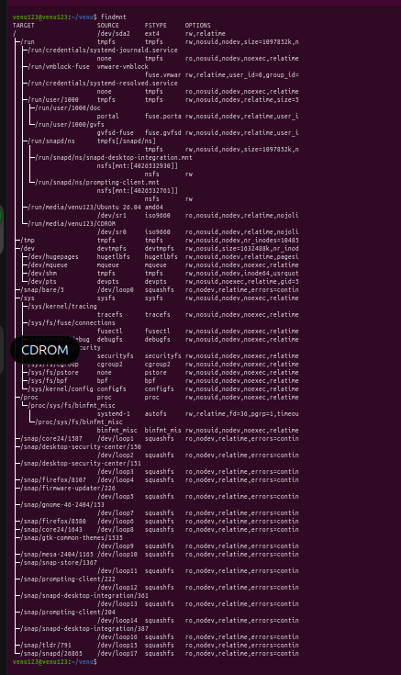

Command: lsblk
Description: Lists block devices and partition layouts
Example: lsblk


📝 Text Viewing & Editing
Command: nano
Description: Friendly command line text editor
Example: nano filename.txt

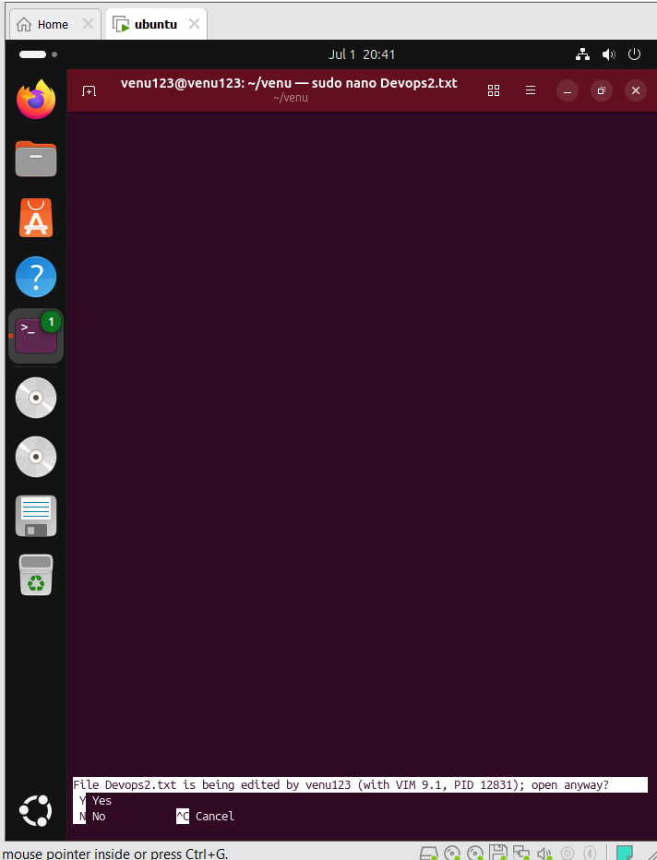

Command: vimtutor
Description: Starts interactive built-in VIM tutorial training
Example: vimtutor

The vimtutor command launches an excellent, built-in interactive text book designed to teach you the absolute basics of the vim text editor in about 25 to 30 minutes.
Here is exactly how to manage and exit the tutor.

🚪 How to Exit vimtutor
Because vimtutor runs directly inside the Vim editor, your mouse will not work to close it. You must use Vim commands.
- Press the Esc key on your keyboard a few times (this ensures you are in "Normal Mode").
- Type exactly :q! and press Enter.
- What :q! means: : starts a command, q means quit, and ! means force quit without saving any changes you made during practice.

💡 Use and Purpose of vimtutor
Unlike standard documentation, vimtutor creates a temporary copy of a text file for you to intentionally modify, delete, and mess up while learning.
It teaches you essential developer skills directly on your keyboard without touching a mouse:
- Navigation: Moving the cursor using h (left), j (down), k (up), and l (right).
- Editing: How to insert text (i), delete characters (x), or delete whole words (dw).
- Undo/Redo: Fixing mistakes quickly using u (undo) and Ctrl + R (redo).
- File Management: How to properly save your work (:wq) or exit safely.

Command: vi
Description: Opens original Unix text editor tool
Example: vi filename.txt

The vi command opens a powerful, lightweight text editor built directly into almost every Linux system. It is heavily used by system administrators to quickly modify configuration files, write scripts, and edit text without needing a graphical desktop interface.🚪 How to Save and Exit vivi uses a modal system, meaning keys do different things depending on your current mode. Before typing any exit command, always press the Esc key first to ensure you are in "Normal Mode."Save and Exit: Type :wq and press Enter (w = write/save, q = quit)Exit Without Saving: Type :q! and press Enter (q = quit, ! = force/discard changes)Quick Keyboard Shortcut: Press Shift + Z Z (capital ZZ) to quickly save and exit.🛠️ The 3 Basic Steps to Use viIf you want to create or edit a file named script.sh, follow this exact workflow:Open the file:bashvi script.sh
Use code with caution.Switch to typing mode: Press the i key on your keyboard. You will see -- INSERT -- appear at the bottom left. You can now type your text normally.Finish and Save: Press Esc to stop typing mode, then type :wq and press Enter to return to your regular terminal screen.

Command: vim
Description: Opens advanced text editor with modern features
Example: vim filename.txt

vim (Vim Improved) is the updated, more powerful version of the older vi editor. It adds helpful features like color-coded text (syntax highlighting), a visual selection mode, and a multi-level undo history.

🚪 How to Save and Exit vim
Just like vi, you must always press the Esc key first to ensure you are in "Normal Mode" before typing a command.
- Save and Exit: Type :wq and press Enter (write and quit)
- Fastest Save and Exit: Type :x and press Enter (saves only if changes were made, then quits)
- Exit Without Saving: Type :q! and press Enter (discards all changes)

🛠️ The 3 Basic Steps to Use vim
To create or edit a file named demo.txt, follow this exact workflow:
- Open the file:
bash
vim demo.txt
Use code with caution.
- Start typing: Press the i key. Look for -- INSERT -- at the bottom left. Type your text.
- Save your work: Press Esc, type :wq, and press Enter to return to your normal terminal.

🌟 Key Differences: Why Choose vim over vi?
- Visual Mode: Pressing v lets you highlight blocks of text with arrow keys to copy, cut, or delete them all at once.
- Syntax Highlighting: Automatically colors programming code and configuration files, making errors easy to spot.
- Search Highlighting: Highlighting stays on matching words when you search for text using the / key.

Command: more
Description: Views file text screen by screen
Example: more filename.txt

The more command is a classic terminal tool used to view the contents of a long text file one screenful at a time.
It prevents your terminal from being flooded with thousands of lines of text all at once, allowing you to read comfortably at your own pace.

🚪 How to Navigate and Exit more
When you open a file with more, it pauses at the bottom of your screen. Use these single-key shortcuts to navigate (do not press Enter unless specified):
- Exit Immediately: Press q (quits back to the terminal)
- Scroll Down One Line: Press Enter
- Scroll Down One Full Screen: Press Spacebar
- Search for a Word: Type /keyword and press Enter (press n to find the next match)

🛠️ Common and Useful Examples
- View a large log file or text file:
bash
more system.log
Use code with caution.
- Combine with other commands (Piping):
If a command outputs too much text to fit on your screen, send it into more:
bash
ls -la /usr/bin | more
Use code with caution.

🆚 Modern Alternative: more vs less
Linux systems also have a newer command called less (derived from the joke "less is more").
- The major limitation of more: It can only scroll forward/down. You cannot scroll back up to reread lines.
- Why less is better: The less command allows you to use your Up and Down arrow keys or the b key to scroll backward and forward freely

Command: less
Description: Advanced text viewer with backward navigation
Example: less filename.txt

The less command is the modern, upgraded version of more. It allows you to view long files or command outputs with full freedom to scroll both forward and backward without loading the entire file into memory, making it incredibly fast even for massive files.

🚪 How to Navigate and Exit less
When you open a file with less, your terminal turns into a readable screen. Use these keyboard shortcuts to navigate:
- Exit Immediately: Press q (quits back to the normal terminal prompt)
- Scroll Down One Line: Press the Down Arrow or Enter
- Scroll Up One Line: Press the Up Arrow
- Page Down (Next Screen): Press Spacebar or Page Down
- Page Up (Previous Screen): Press b or Page Up
- Jump to End of File: Press G (Capital G)
- Jump to Start of File: Press g (Lowercase g)

🔍 Searching Inside less
- Search Forward: Type /keyword and press Enter
- Search Backward: Type ?keyword and press Enter
- Next Match: Press n
- Previous Match: Press N (Shift + n)]

🛠️ Common and Useful Examples
- Read a large file safely:
bash
less syslog.log
Use code with caution.
- Pause a long terminal output (Piping):
If ls or any command spits out too much text, catch it with less:
bash
ls -lh /usr/bin | less

Command: head
Description: Displays first few lines of file text
Example: head filename.txt

head (View Top Lines)
- Purpose: Displays the first few lines of a file (defaults to the first 10 lines) so you can quickly inspect headers or metadata.
- How to run: head filename.txt
- Custom line count: head -n 20 filename.txt (shows the first 20 lines)
- How to exit: Exits automatically.

Command: tail
Description: Displays last few lines of file text
Example: tail filename.txt

tail (View Bottom Lines)
- Purpose: Displays the last few lines of a file (defaults to the last 10 lines). It is most frequently used to check recent error logs.
- How to run: tail filename.txt
- Live follow mode: tail -f filename.txt (leaves the terminal open and prints new text in real-time as it gets added to the file).
- How to exit: Standard tail exits automatically. If you use -f mode, press Ctrl + C to stop and exit

Command: cat
Description: Outputs entire file content to terminal screen
Example: cat filename.txt

cat (Concatenate)
- Purpose: Displays the entire contents of a file on your screen instantly. It is best used for short files.
- How to run: cat filename.txt
- How to exit: It exits automatically when it hits the end of the file. If it gets stuck on a massive file, press Ctrl + C

Command: cat -A
Description: Outputs file content including hidden special characters
Example: cat -A filename.txt

cat -A (Show All Hidden Characters)
- Purpose: Displays hidden formatting characters like tabs (shows as ^I) and line breaks/ends (shows as $). Essential for debugging spacing issues in scripts or configuration files.
- How to run: cat -A filename.txt
- How to exit: Exits automatically.

Command: tac
Description: Prints text file lines in reverse order
Example: tac filename.txt

tac (Reverse Cat)
- Purpose: Works exactly like cat, but prints the file upside down (in reverse order). It displays the last line first and the first line last. Great for reading recent log entries.
- How to run: tac filename.txt
- How to exit: Exits automatically.

🔍 Advanced Text Processing
Command: grep
Description: Filters text using specific matching patterns
Example: grep 'pattern' file.txt

grep (Global Regular Expression Print)
- Purpose: Searches files for text lines that match a specific keyword or pattern.
- How to Run:
  - Find a simple keyword: grep "error" system.log
  - Ignore text case (capital or lowercase): grep -i "error" system.log
  - Count the number of matches: grep -c "failed" auth.log
- How to Exit: Exits automatically after finding all matches. Press Ctrl + C if searching a massive file or stream takes too long.

Command: awk
Description: Processes structural text data and layout columns
Example: awk '/pattern/ {print}' file.txt

awk (Pattern Scanning & Processing)
- Purpose: A complete programming language designed for advanced data extraction, column layout manipulation, and math calculations on log files or reports.
- How to Run:
  - Print only the 1st and 3rd column of any white-spaced layout or log:
bash
awk '{print $1, $3}' system.log
Use code with caution.
  - Find lines where the 2nd column is exactly equal to the number 200:
bash
awk '$2 == 200 {print $0}' web_server.log

Command: sed
Description: Modifies text stream data dynamically on line
Example: sed 's/old/new/' file.txt

sed (Stream Editor)
- Purpose: Automatically modifies, replaces, inserts, or deletes text inside a file without you having to open it in an editor like vim or nano.
- How to Run:
  - Replace the word "old" with "new" in the output terminal text:
bash
sed 's/old/new/' document.txt
Use code with caution.
  - Permanently edit and save the replacement inside the file (-i flag):
bash
sed -i 's/old/new/g' document.txt

Command: tr
Description: Translates or deletes targeted specific characters
Example: tr '[:lower:]' '[:upper:]' < file.txt

tr (Translate or Replace)
- Purpose: Replaces, deletes, or squeezes specific characters. It only accepts text from a data stream (piping), not directly from a file name.
- How to Run:
  - Convert all lowercase text to uppercase:
bash
cat text.txt | tr 'a-z' 'A-Z'
Use code with caution.
  - Delete all numerical digits from a text stream:
bash
cat data.txt | tr -d '0-9'

Command: cut
Description: Extracts specific sections or columns from text
Example: cut -d':' -f1 file.txt

cut (Column Extractor)
- Purpose: Cuts out specific columns or sections from each line of text based on a delimiter (like a comma, space, or colon).
- How to Run:
  - Extract the 1st column from a colon-separated file (like /etc/passwd):
bash
cut -d ":" -f 1 /etc/passwd
Use code with caution.
  - Extract characters 1 through 10 from a file:
bash
cut -c 1-10 names.txt
Use code with caution.
- How to Exit: Exits automatically.

Command: sort
Description: Rearranges text lines alphabetically or numerically
Example: sort file.txt

How to Control the Sorting Direction
- Sort Alphabetically (Default): Rearranges lines from A to Z.
bash
sort names.txt
Use code with caution.
- Sort in Reverse Order: Rearranges lines from Z to A or highest to lowest using the -r flag.
bash
sort -r names.txt
Use code with caution.

🛠️ Common and Essential Flags
- -n (Numerical Sort): Standard sorting treats numbers as text (meaning "10" comes before "2"). Use -n to sort by true mathematical value.
bash
sort -n scores.txt
Use code with caution.
- -u (Unique Sort): Sorts the file and automatically removes any identical duplicate lines.
bash
sort -u names.txt
Use code with caution.
- -k (Sort by a Specific Column): If your file has columns (like a table), specify which column to base the sort on.
bash
sort -k 2 data.txt
Use code with caution.
(Sorts the file based entirely on the contents of the second column).

💡 Combining sort with Other Commands
The sort command is most powerful when combined with the uniq command to count occurrences in log files:
bash
cat access.log | cut -d " " -f 1 | sort | uniq -c | sort -nr
Use code with caution.
- What this does: Extracts IP addresses (cut) → groups identical ones together (sort) → counts how many times each IP appeared (uniq -c) → sorts the final list from highest to lowest traffic (sort -nr).

🌐 Server Connection & Identity
Command: su
Description: Switches current user identity environment session
Example: su username

The su (Switch User) command allows you to change your current terminal session to a different user account without logging out of Linux.
🚪 How to Execute and Exit
- Switch to another account: Type the command with the username.
bash
su username
Use code with caution.
(It will ask for that specific user's login password).
- Exit and return to your account: Type exit or press Ctrl + D to close the switched session and return to your original prompt.

🛠️ Common and Essential Use Cases
- Switch to the Root (Administrator) Account:
bash
su -
Use code with caution.
(The - flag is critical because it loads the root user's complete environment, path variables, and home directory).
- Run a single command as another user without switching permanently:
bash
su - username -c "mkdir shared_folder"
Use code with caution.
(The -c flag runs the command inside quotes and immediately returns to your normal account).

🆚 Modern Security: su vs sudo
Feature | su (Switch User) | sudo (Superuser Do)
Password Needed | Requires the target user's password. | Requires your own login password.
Control | Gives total access to the account. | Grants limited access to specific commands.
Tracking | Harder to log who did what. | Logs every command in /var/log/auth.log.
- Security Best Practice: In modern Ubuntu systems, the root account is locked by default. Developers prefer using sudo before commands instead of switching profiles completely with su.

